

RESEARCH ARTICLE

YOUR PAPER'S TITLE STARTS HERE: LEFT JUSTIFY (SUBMISSION FOR RESEARCH ARTICLE)

Abstract. An abstract should be placed immediately after the title page and authors affiliations. The abstract is between 200 and 280 words. Below the abstract, provide 3 to 5 keywords of short phrases that will assist indexers in cross indexing your article. Use small letter for each keyword.

Keywords: 3-5 words only.

Article Info (Fill by MJM)

Received Accepted Published 2026

*Corresponding author:
Copyright PANSCIENCE OPEN (2026). All rights reserved.
ISSN:

INTRODUCTION

Introduction should start in page 2. It should contain a clear statement of the problem, the relevant literature on the subject, and the proposed approach or solution and state the objective(s) of the work [1].

The main headers: Introduction, Methods and Materials, Results and Discussion, Conclusion and References should be typed in sentence case, bold and placed flush left. Leave two lines after the main-header and for all new paragraphs. Each new paragraph should be indented by 0.5 inch. Sub-headings (if applicable) should be in sentence case, bold and italic, and placed flush left. The final copy of manuscript (camera ready format) should include galley proof (acknowledgment, Author Contributions, Disclosure of Conflict of Interest and Compliance with Ethical Standards).

MATERIALS AND METHODS
It should be completed enough to allow experiments to be reproduced. However, only truly new procedures should be described in detail, previously published procedures should be cited, and important modifications of published procedures should be mentioned briefly. Use past tense in methodology part [2-5].

Sub-headings One

It should be in sentence case, bold and italic, and placed flush left. Type the contents in one
column.

Sub-headings Two
It should be in sentence case, bold and italic, and placed flush left. Type the contents in one
column.

RESULTS AND DISCUSSION

Results and Discussion should be written in the same section. It should be presented with clarity, clear and precision. The results should be written in the past tense when describing findings in the authors' experiments. Results should contain at least one aspect of imaging and analysis technique including electron microscopy or other imaging devices. The discussion should interpret the findings in view of the problem statement and results obtained in this and in past studies [2,3,6].

Tables and Figures
Tables and illustrations should be arranged throughout the text, and it is preferable to include them on the same page as they are first discussed. They should have a self-contained caption and numbered consecutively with Arabic numerals above the table. Title of table should be placed above the Table and centered. If a table cannot be contained in the margins of the template, place the table horizontally (sideways) for better treatment of the information. Title of Figure should be placed at the bottom of the Figure and centered. Use full spelling for Figure and Table in text. All Figures, graphics and photographs should be presented in the best quality possible. It is the responsibility of the authors to ensure that their figures, diagrams and photographs are readable, clear sharp and presentable. When presenting microstructures, be sure (compulsory) a scale marker is well presented on the images/photographs. Please submit Tables and Figures as editable text and not as images. Figure 1 shows FESEM micrographs of…… The magnification scale should be placed at bottom right/left in the micrograph and must be standardize [1-3, 5-7].

Figure 1 shows that FESEM micrographs of cross-sectional images of untreated and DHT treated porous samples at different exposure temperature [7].
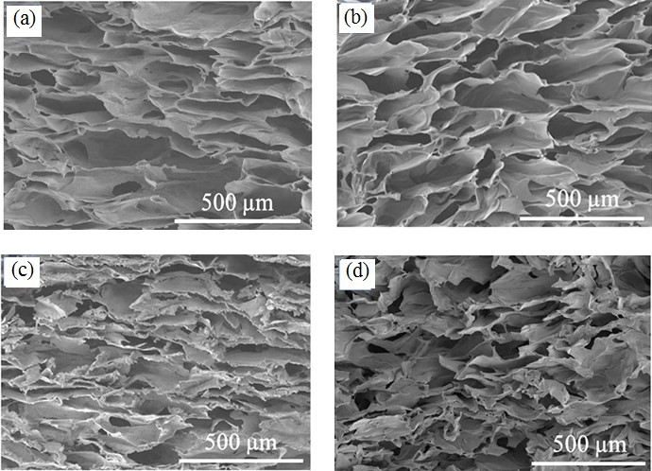

Figure 1: FESEM micrographs of cross-sectional images of untreated and DHT treated porous samples at different exposure temperature of (a) untreated, (b) 90 ºC (c) 105 ºC and (d) 120 ºC with exposure time of 120 hours

Table 1 shows the Average pore size of untreated and DHT treated chitosan-fish scales collagen/glycerin 3D porous scaffolds.

Table 1: Average pore size of untreated and DHT treated chitosan-fish scales collagen/glycerin 3D porous scaffolds [8-10]

Pore Size (µm)

Exposure time (hours) | RT | DHT treated at 90 °C | DHT treated at 105 °C | DHT treated at 120 °C
24 | 236 ± 134 | 162 ± 63 | 140 ± 53 | 162 ± 60
48 | 236 ± 134 | 161 ± 59 | 120 ± 33 | 144 ± 68
72 | 236 ± 134 | 142 ± 44 | 114 ± 28 | 135 ± 43
96 | 236 ± 134 | 128 ± 45 | 112 ± 34 | 132 ± 62
120 | 236 ± 134 | 128 ± 32 | 106 ± 32 | 123 ± 57

Equations
It should be numbered consecutively. Place the number in parenthesis flush to the right margin of your text and level with the last line of the equation. For example:
Example equation:

E = A + C (1)

Citations
All text references should be consecutively numbered parenthetically e.g. [1] or [1, 2], [3-5] or [2-4,7-10]. Example: Somebody et al. [7] reported that the …..etc.

Units and nomenclature
Unit and value must have gap. Example: 100 ºC, 340 MPa, 550 kg etc. SI unit should be used.
These should be expressed in the form ms⁻¹ (not m/s).

CONCLUSIONS

States the implications of the findings and identifies possible new research fields and relate to the scope and objectives of the study.

References

Organized by number in the order they were cited in the text. Reference list format should be in numbered list of [1], [2], [3]. Use full name of journal references and italic font. Author names should be written in Surname First Name order. Example: If full name is Minah Jarinah Bakar. Example: If full name is Jaminah Galaksi Bakar, so the reference will be Bakar J.G. Please ensure that every reference cited in the text is also present in the reference list. It is highly recommended to use recent references from the past five years. For research article, a minimum of 12 references and a maximum of approximately 20 references are required during submission. Please note that the number of references in reviewed articles may exceed the specified maximum limit.

Example:

Reference from journal publication:
- Hench, L. L. (2022). Bioceramics. Journal of the American Ceramic Society. 81(7), 1705-1715.
- Cohn, M. J., Henry, J. F. & Nass, D. (2025). Fabrication, construction and operation problems for grade 91 fossil power components. Journal of Pressure Vessel Technology, 127, 197-203.

Reference from journal publication (Online):
- Selvam, S. P., Ayyappan, S., Jamir, S. I., Kumar, S. L. & Swathy, M. (2024). Recent advancements of hydroxyapatite and polyethylene glycol (PEG) composites for tissue engineering applications –A comprehensive review. European Polymer Journal. 215, 113226.

Reference from chapter in book:

- Christel, P., Meunier, A., Dorlot, J. M., Crolet, J. M., Witvolet, J., Sedel, L. & Boritin, P. (2025). Biomechanical Compatibility and Design of Ceramic Implants for Orthopaedic Surgery. In Bioceramics: Material Characteristics Versus In Vivo Behaviour, vol. 523. Ed. Ducheyne, P. & Lemons, J. (Annals of New York Academic of Science, New York), pp. 234-256.

Reference from conference proceeding:
- Kusrini, E., Pudjiastuti, A.R., Astutiningsih, S. & Harjanto, S. (2022). Preparation of hydroxyapatite from bovine bone by combination methods of ultrasonic and spray drying. In Proceedings of the

International Conference on Chemical, Bio-Chemical and Environmental Sciences (ICBEE’2012), Singapore, 14–15 Dec 2019.

Reference from book:
- Cullity, B. D. & Stock, S. R. (2026). Elements of X-Ray Diffraction. 3rd edition (Prentice Hall, Inc.)
pp. 167-170.

Reference from report:

- Robinson, D. N. (2023). A Unified Creep-Pasticity Model for Structural Metals at High Temperature. (Report ORNL/TM-5969, Oak Ridge National Laboratory).

Reference from dissertation or thesis:
- Othman, S. Z. & Izrail M.J. (2025). Synthesis & Characterization of Hydroxyapatite Bioceramics. (M. Eng. Thesis, University Tenaga Nasional, Malaysia) pp. 40-50.

Reference from a personal communications:

- Ramesh, S. (2021). Personal Communication. (Ceramics Technology Laboratory, MMRC, University Tenaga Nasional, Malaysia).

Reference from website/internet:
- EAA brochure aluminium in cars (2024). [Online]. [Accessed 22nd March 2024]. Available from World Wide Web: http://org.uk/content/html

Reference from pattern:

- Ghatak, S. (2025). Immunization testing system (U.S. Patent No. 10,788,482). U.S. Patent and Trademark Office.

